1.Given a number with maximum of 100 digits as input, find the difference between the sum

of odd and even position digits.

Input Format:

Take a number in the form of String from stdin.

Output Format:

Print the difference between sum of even and odd digits

Example input:

1453

Output:

1

Explanation:

Here, sum of even digits is 4 + 3 = 7

sum of odd digits is 1 + 5 = 6.

Difference is 1.

Note that we are always taking absolute difference

Program:

def differenceSum(n):

n=str(n)

l = [0 ,0]

for i in range(len(n)):

if i % 2 == 0:

l[0] = l[0] + int(n[i])

else:

l[1] = l[1] + int(n[i])

return(abs(l[0] - l[1]))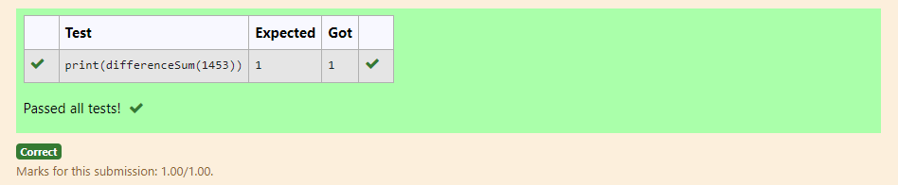

2. A number is considered to be ugly if its only prime factors are 2, 3 or 5.

[1, 2, 3, 4, 5, 6, 8, 9, 10, 12, 15, …] is the sequence of ugly numbers.

Task:

complete the function which takes a number n as input and checks if it's an ugly number.

return ugly if it is ugly, else return not ugly

Hint:

An ugly number U can be expressed as: U = 2^a * 3^b * 5^c, where a, b and c are nonnegative integers.

**For example:**

| **Test** | **Result** |
| --- | --- |
| print(checkUgly(6)) | ugly |
| print(checkUgly(21)) | not ugly |

Program:

def checkUgly(n):

if n <= 0:

return "not ugly"

for p in [2, 3, 5]:

while n % p == 0:

n //= p

return "ugly" if n == 1 else "not ugly"

)

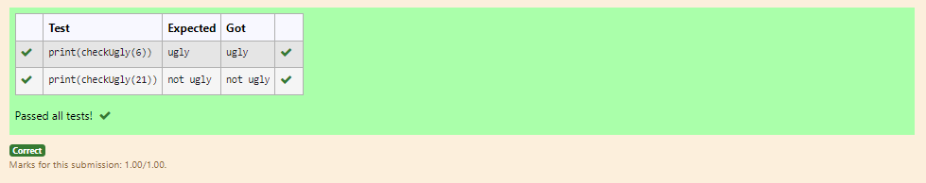

3. Write a code to check whether product of digits at even places is divisible by sum of digits

at odd place of a positive integer.

Input Format:

Take an input integer from stdin.

Output Format:

Print TRUE or FALSE.

Example Input:

1256

Output:

TRUE

Example Input:

1595

Output:

FALSE

**For example:**

| **Test** | **Result** |
| --- | --- |
| print(productDigits(1256)) | True |
| print(productDigits(1595)) | False |

Program:

def productDigits(number):

number_str=str(number)

product_even=1

sum_odd=0

for i,digit_char in enumerate(number_str):

digit=int(digit_char)

if(i+1)%2==0:

product_even*=digit

else:

sum_odd+=digit

return product_even%sum_odd==0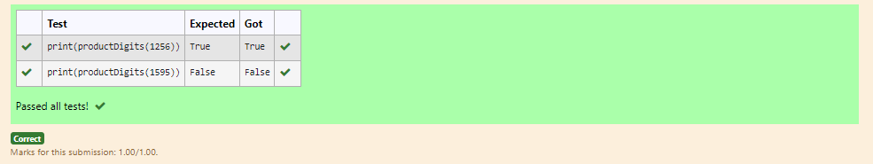

4.  An e-commerce company plans to give their customers a special discount for Christmas.

They are planning to offer a flat discount. The discount value is calculated as the sum of all

the prime digits in the total bill amount.

Write an algorithm to find the discount value for the given total bill amount.

Constraints

1 <= orderValue< 10e100000

Input

The input consists of an integer orderValue, representing the total bill amount.

Output

Print an integer representing the discount value for the given total bill amount.

Example Input

578

Output

12

**For example:**

| **Test** | **Result** |
| --- | --- |
| print(christmasDiscount(578)) | 12 |

Program:

def is_prime_digit(digit):

return digit in [2,3,5,7]

def christmasDiscount(n):

s=discount=0

prime_digitis=[2,3,5,7]

for digit in str(n):

digit=int(digit)

if is_prime_digit(digit):

discount+=digit

return discount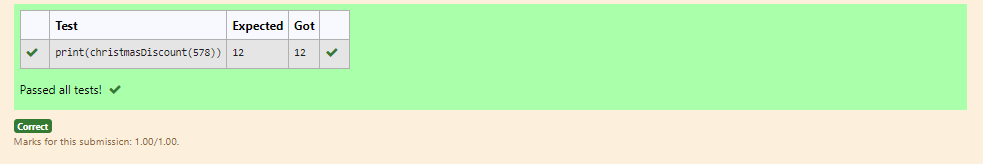

5.  complete function to implement coin change making problem i.e. finding the minimum

number of coins of certain denominations that add up to given amount of money.

The only available coins are of values 1, 2, 3, 4

Input Format:

Integer input from stdin.

Output Format:

return the minimum number of coins required to meet the given target.

Example Input:

16

Output:

4

Explanation:

We need only 4 coins of value 4 each

Example Input:

25

Output:

7

Explanation:

We need 6 coins of 4 value, and 1 coin of 1 value

Program:

def coinChange(target):

coins=[1,2,3,4]

dp=[float('inf')]*(target+1)

dp[0]=0

for i in range(1,target+1):

for coin in coins:

if coin<=i:

dp[i]=min(dp[i],dp[i-coin]+1)

return dp[target]

